## CHAPTER – 1

## INTRODUCTION

“The worst thing about a disability is that people see it before they see you”

- Dr. Laugesen

People with visual impairment are one of the most marginalised and excluded groups in society. Facing daily discrimination in the form of negative attitudes, lack of adequate policies and legislation, they are effectively barred from realising their rights to health care, education, and even survival.

Saksham is an open-source Android app. It connects the vernacular audience, visually impaired to be precise with users of the same kind or normal citizens.

Technology has been changing our lives drastically, nowadays smartphones are part of our lives as a personal assistant however visual impaired are not able to use it efficiently. To enhance the acceptance of smartphones evenly by the visual impaired community our proposed android application makes the day-to-day usage of smartphones apps convenient and easy.

It provides several features like object detection using monocular camera, audio book, changing the audio profile of the misplaced phone, getting the exact location of the misplaced phone, getting the number of any selected contact using passcode.

## CHAPTER – 2

**LITERATURE SURVEY**

Literature survey or a literature study is a text of a scholarly paper, which includes the current knowledge including substantial finding as well as theoretical and methodological contributions to a particular topic.

* DISABILITY AND ASSISTIVE TECHNOLOGY:Omer Faruk ISLIM, Middle East Technical University, islim@metu.edu.tr, Kursat CAGILTAY, Middle East Technical University, kursat@metu.edu.tr,

There are nearly one billion people with disabilities all over the world and more than a hundred million people have heavy disabilities and need assistance (WHO, 2012). Disability is not a fault and people with disabilities are a part of our community and have equal rights with us. According to United Nations

Convention on the Rights of Persons with Disabilities (CRPD) (2006), providing assistance to disabled people to maximise functioning, support independence and, participate in the community is the duty of governments.The Assistive Technology is an umbrella term that covers many technologies, devices or only methods to

support people with disabilities.The assistive technology varies from a low-tech pen grip to a high-tech multi-touch tablet pc. The common point of all is removing the barriers in front of the disabled people.

⚫ Understanding User Centred Design (UCD) for People with Special Needs  
Harold W. ThimblebyPublished in ICCHP 2008  
"User centred design" (UCD) has become a central, largely unquestioned, tenet of good practice for the design of interactive systems.

With the increasing recognition of the importance of special needs in influencing design, UCD needs to be re-examined, in particular to be clear about the difference between using its methods, which may not suit special needs, and achieving its objectives.

This paper introduces a simple two-category classification of special needs, to which UCD applies very differently and which are heavily affected by developments in technology; in other words, the role of UCD, particularly with respect to special needs, will continue to change and demand close scrutiny.

* Obstacle Detection and Avoidance System Based on Monocular Camera and Size Expansion Algorithm for UAVs.

Obstacle detection and warning can improve the mobility as well as the safety of visually impaired people specially in unfamiliar environments. For this, firstly, obstacles are detected and localised and then the information of the obstacles will be sent to the visually impaired people by using different modalities such as voice, tactile, vibration. In this paper, we present an assistive system for visually impaired people based on the matrix of electrode and a mobile Kinect. This system consists of two main components: environment information acquisition and analysis and information representation. The first component aims at capturing the environment by using a mobile Kinect and analysing it in order to detect the predefined obstacles for visually impaired people, while the second component tries to represent obstacle’s information under the form of electrode matrix.

* Using TensorFlowLite on Android Devices <https://medium.com/tensorflow/using-tensorflow-lite-on-android-9bbc9cb7d69d>

[TensorFlow Lite](https://www.tensorflow.org/mobile/tflite/) is TensorFlow’s lightweight solution for mobile and embedded devices. It lets you run machine-learned models on mobile devices with low latency, so you can take advantage of them to do classification, regression or anything else you might want without necessarily incurring a round trip to a server.

It’s presently supported on Android and iOS via a C++ API, as well as having a Java Wrapper for Android Developers. Additionally, on Android Devices that support it, the interpreter can also use the Android Neural Networks API for hardware acceleration, otherwise it will default to the CPU for execution. In this article I’ll focus on how you use it in an Android app.

TensorFlow Lite is comprised of a runtime on which you can run pre-existing models, and a suite of tools that you can use to prepare your models for use on mobile and embedded devices.

It’s not yet designed for training models. Instead, you train a model on a higher powered machine, and then convert that model to the .TFLITE format, from which it is loaded into a mobile interpreter.

## CHAPTER – 3

**PROBLEM IDENTIFICATION**

Obstacle detection and warning can improve the mobility as well as the safety of visually impaired people specially in unfamiliar environments. For this, firstly, obstacles are detected and localised and then the information of the obstacles will be sent to the visually impaired people by using different modalities such as voice and vibration. In this project, we present an assistive system for visually impaired people based on the TensorFlow Lite and an Android Device with Camera. This system consists of two main components: environment information acquisition and analysis and information representation. The first component aims at capturing the environment by using a and analysing it in order to detect the predefined obstacles for visually impaired people, while the second component tries to represent obstacle’s information under the TensorFlow Lite Object Detection Model for identifying distinct objects.

## CHAPTER – 4

**OBJECTIVES**

* To make this app beneficial for the visually impaired and aid them in every possible way.
* Provide the best interface which makes it user-friendly.
* Obstacle Detection using Monocular Camera, Size Expansion Algorithm and TensorFlow Lite
* Get the Phone Numbers from the preset passcode if Phone is left at Home or somewhere else without the use of Internet and only a Simple SMS will do.
* Get the location if phone is lost using simple SMS.
* Read rich text as audio-book using text-to-speech in regional languages using simple SMS.
* Change the audio profile of any phone using simple SMS.

## CHAPTER – 5

**REQUIREMENTS**

**Hardware:**

* Android Phone,
* Laptop
* Phone Camera.

**Software:**

* Android Studio
* Firebase API
* TensorFlowLite
* PyCharm IDE Community Edition.
* Python 3.7x

## CHAPTER – 6

**METHODOLOGY**

**Object Detection:**

Object Detection is the process of finding real-world object instances like cars, bikes, TVs, flowers, and humans in still images or videos. It allows for the recognition, localisation, and detection of multiple objects within an image, which provides us with a much better understanding of an image as a whole. It is commonly used in applications such as image retrieval, security, surveillance, and advanced driver assistance systems (ADAS).

Object detection can be done in multiple ways:

* Feature-based object detection
* Viola Jones object detection
* SVM classifications with HOG features
* Deep learning object detection

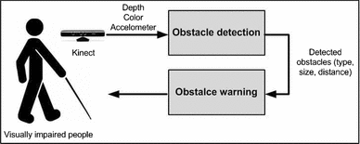

**TensorFlow Lite:**

[TensorFlow Lite](https://www.tensorflow.org/mobile/tflite/) is TensorFlow’s lightweight solution for mobile and embedded devices. It lets you run machine-learned models on mobile devices with low latency, so you can take advantage of them to do classification, regression or anything else you might want without necessarily incurring a round trip to a server.

It’s presently supported on Android and iOS via a C++ API, as well as having a Java Wrapper for Android Developers. Additionally, on Android Devices that support it, the interpreter can also use the Android Neural Networks API for hardware acceleration, otherwise it will default to the CPU for execution. In this article I’ll focus on how you use it in an Android app.

TensorFlow Lite is comprised of a runtime on which you can run pre-existing models, and a suite of tools that you can use to prepare your models for use on mobile and embedded devices.

It’s not yet designed for training models. Instead, you train a model on a higher powered machine, and then convert that model to the .TFLITE format, from which it is loaded into a mobile interpreter.

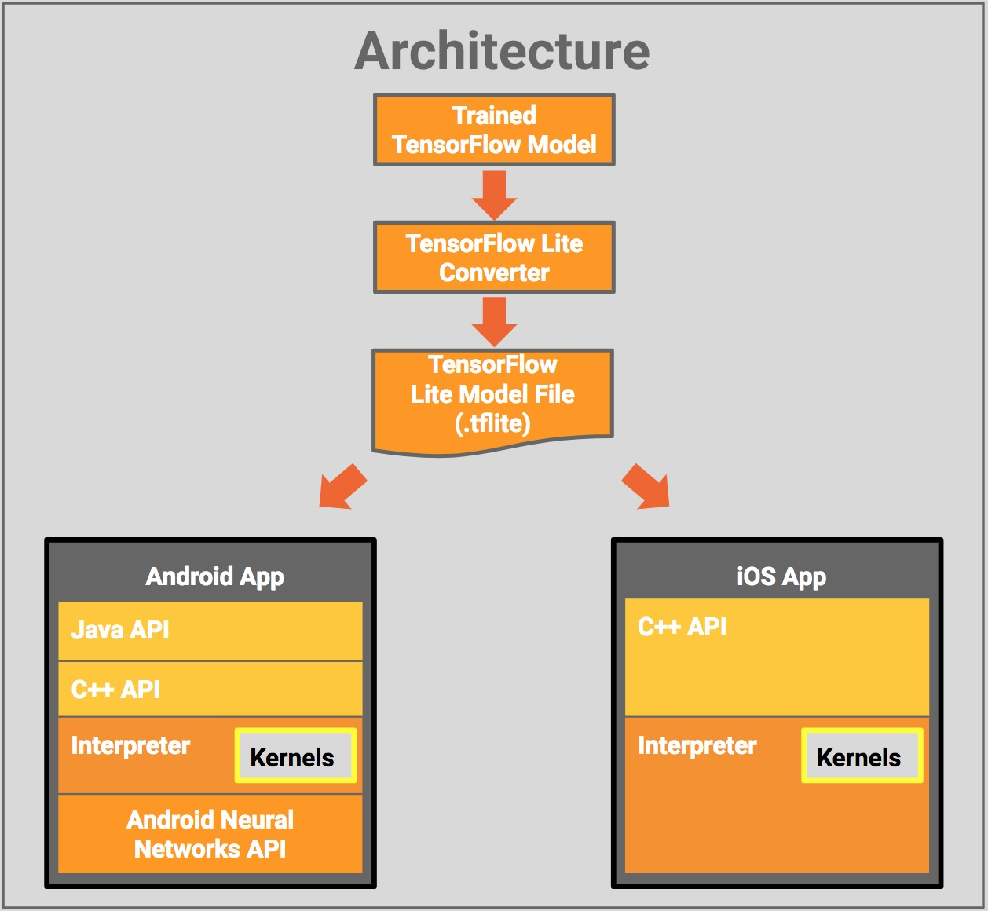

TensorFlow Lite is presently in developer preview, so it may not support all operations in all TensorFlow models. Despite this, it does work with common Image Classification models including Inception and MobileNets. In this article you’ll look at running a MobileNet model on Android. The app will look at the camera feed and use the trained MobileNet to classify the dominant images in the picture.

## CHAPTER – 7

**PROPOSED WORK PLAN**

Humans learn to recognise objects or humans by learning starting from their birth. Same idea has been utilised by incorporating the intelligence by training into a camera using neural networks and TensorFlow. This enables to have the same intelligence in cameras, which can be used as an artificial eye and can be used in many areas such as surveillance, detection of objects/things etc.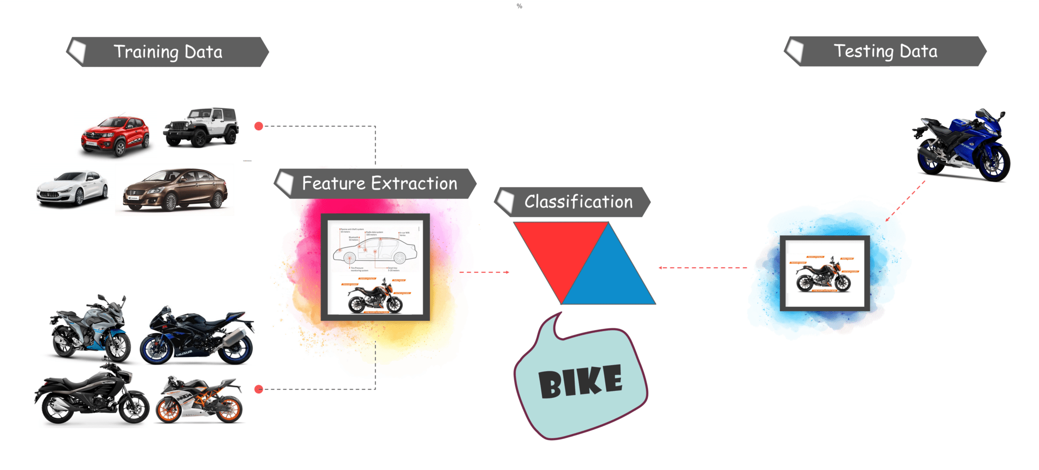

Every object detection algorithm has a different way of working, but they all work on the same principle.

**Feature Extraction:**They extract features from the input images at hand and use these features to determine the class of the image. Be it through MatLab, Open CV, Viola Jones, or deep learning.

Let’s move along to the tutorial and understand what Tensorflow is and what its components are.

**What Is TensorFlow?**

* Tensorflow is Google’s open source machine learning framework for dataflow programming across a range of tasks. Nodes in the graph represent mathematical operations, while the graph edges represent the multi-dimensional data arrays (tensors) communicated between them.
* Tensors are just multidimensional arrays, an extension of 2-dimensional tables of data with a higher dimension. There are many features of Tensorflow that make it appropriate for deep learning. So, without further ado, let’s see how we can implement Object Detection using Tensorflow.

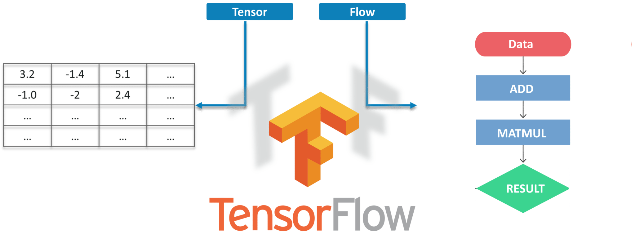

**Prerequisites**

Before working on the demo, let’s have a look at the prerequisites:

* Python 3.7
* TensorFlow Lite
* TensorBoard
* [Protobuf v3.4 or above](https://github.com/google/protobuf/releases)
* Android Studio

**Building an Android App to use TensorFlow Lite**

To build an Android App that uses TensorFlow Lite, the first thing you’ll need to do is add the tensorflow-lite libraries to your app. This can be done by adding the following line to your build.gradle file’s dependencies section:

Implementation ‘org.tensorflow:tensorflow-lite:+’

Once you’ve done this you can import a TensorFlow Lite interpreter. An Interpreter loads a model and allows you to run it, by providing it with a set of inputs. TensorFlow Lite will then execute the model and write the outputs, it’s really as simple as that.

import org.tensorflow.lite.Interpreter;

To use it you create an instance of an Interpreter, and then load it with a MappedByteBuffer.

**protected** Interpreter **tflite**;

tflite = **new** Interpreter(loadModelFile(activity));

There’s a helper function for this in the TensorFlow Lite sample on GitHub. Just ensure that getModelPath() returns a string that points to a file in your assets folder, and the model should load.

/** Memory-map the model file in Assets. */

**private** MappedByteBuffer loadModelFile(Activity activity) **throws** IOException {

AssetFileDescriptor fileDescriptor = activity.getAssets().openFd(getModelPath());

FileInputStream inputStream = **new** FileInputStream(fileDescriptor.getFileDescriptor());

FileChannel fileChannel = inputStream.getChannel();

**long** startOffset = fileDescriptor.getStartOffset();

**long** declaredLength = fileDescriptor.getDeclaredLength();

**return** fileChannel.map(FileChannel.MapMode.***READ_ONLY***, startOffset, declaredLength);

}

Then, to classify an image, all you need to do is call the **run** method on the Interpeter, passing it the image data and the labels array, and it will do the rest:

Then Run the app from the build button in Android Studio IDE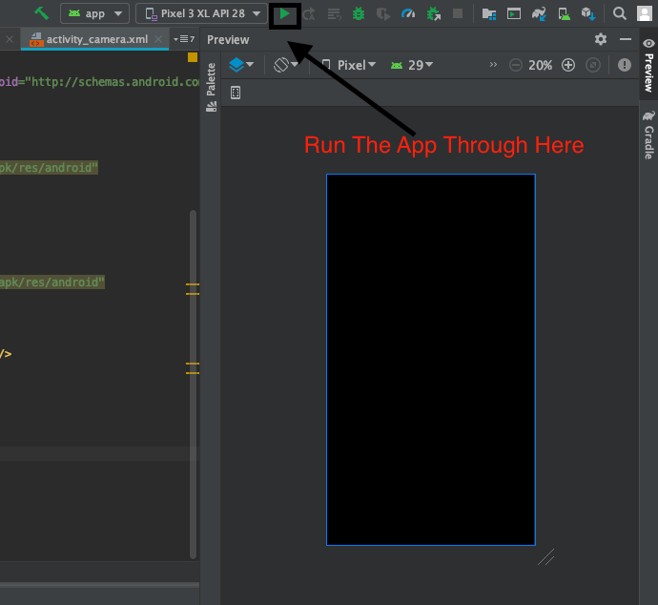

The CameraActivity will take the video stream and convert into Blob Image Array and Use Brute-Force-Matcher algorithm to identify Objects.

Below are some identified examples:

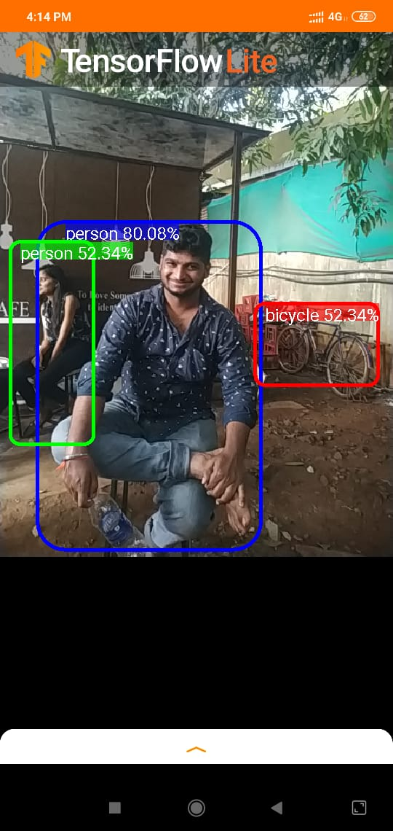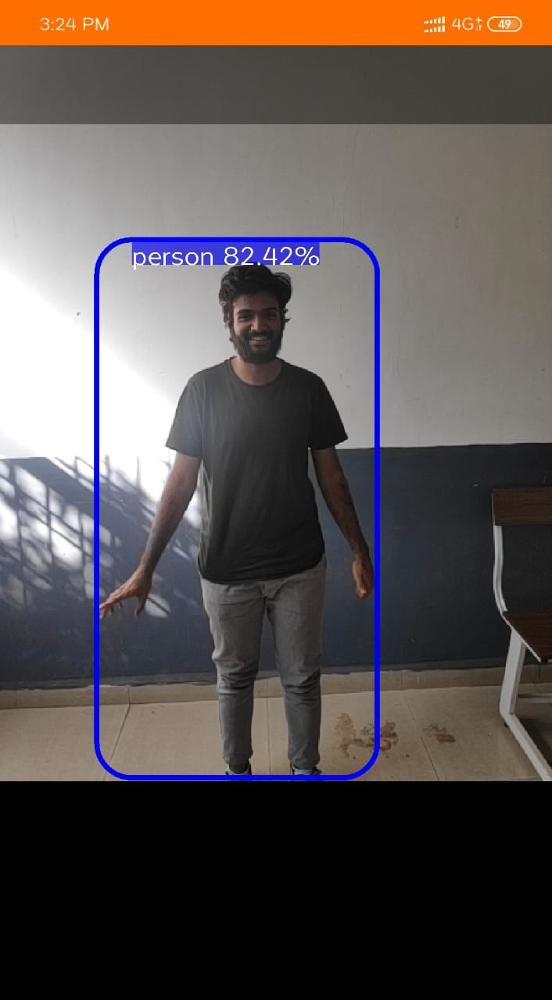

**References**

1. *Bernabei, D., Ganovelli, F., Di Benedetto, M., Dellepiane, M., Scopigno, R.:* A low-cost time-critical obstacle avoidance system for the visually impaired. In: International conference on indoor positioning and indoor navigation (IPIN) (2011)[Google Scholar](https://scholar.google.com/scholar?q=Bernabei%2C%20D.%2C%20Ganovelli%2C%20F.%2C%20Di%20Benedetto%2C%20M.%2C%20Dellepiane%2C%20M.%2C%20Scopigno%2C%20R.%3A%20A%20low-cost%20time-critical%20obstacle%20avoidance%20system%20for%20the%20visually%20impaired.%20In%3A%20International%20conference%20on%20indoor%20positioning%20and%20indoor%20navigation%20%28IPIN%29%20%282011%29)
2. *Calder, D.J.:* Assistive technology interfaces for the blind. In: 3rd IEEE international conference on digital ecosystems and technologies, pp. 318–323, June (2009)[Google Scholar](https://scholar.google.com/scholar?q=Calder%2C%20D.J.%3A%20Assistive%20technology%20interfaces%20for%20the%20blind.%20In%3A%203rd%20IEEE%20international%20conference%20on%20digital%20ecosystems%20and%20technologies%2C%20pp.%20318%E2%80%93323%2C%20June%20%282009%29)
3. Multi-kinect camera calibration. <http://doc-ok.org/?p=295>.
4. *Chen, G., Can, Z., Jun, P.:* An intelligent blind rod and navigation platform based on zigbee technology. In: 2011 International conference on E-Business and E-Government (ICEE), pp. 1–4, May (2011)[Google Scholar](https://scholar.google.com/scholar?q=Chen%2C%20G.%2C%20Can%2C%20Z.%2C%20Jun%2C%20P.%3A%20An%20intelligent%20blind%20rod%20and%20navigation%20platform%20based%20on%20zigbee%20technology.%20In%3A%202011%20International%20conference%20on%20E-Business%20and%20E-Government%20%28ICEE%29%2C%20pp.%201%E2%80%934%2C%20May%20%282011%29)
5. *Hersh, M., Johnson, M.A.:* Assistive Technology for Visually Impaired and Blind People, 1st edn. Springer, London (2008)[CrossRef](https://doi.org/10.1007/978-1-84628-867-8)[Google Scholar](http://scholar.google.com/scholar_lookup?title=Assistive%20Technology%20for%20Visually%20Impaired%20and%20Blind%20People&author=M.%20Hersh&author=MA.%20Johnson&publication_year=2008)
6. *Hoang, V.N., Nguyen, T.H., Le, T.L., Tran, T.T.H., Vuong, T.P., Vuillerme, N.:* Obstacle detection and warning for visually impaired people based on electrode matrix and mobile kinect. In: 2nd National foundation for science and technology development conference on information and computer science (NICS), pp. 54–59, Sept (2015)[Google Scholar](https://scholar.google.com/scholar?q=Hoang%2C%20V.N.%2C%20Nguyen%2C%20T.H.%2C%20Le%2C%20T.L.%2C%20Tran%2C%20T.T.H.%2C%20Vuong%2C%20T.P.%2C%20Vuillerme%2C%20N.%3A%20Obstacle%20detection%20and%20warning%20for%20visually%20impaired%20people%20based%20on%20electrode%20matrix%20and%20mobile%20kinect.%20In%3A%202nd%20National%20foundation%20for%20science%20and%20technology%20development%20conference%20on%20information%20and%20computer%20science%20%28NICS%29%2C%20pp.%2054%E2%80%9359%2C%20Sept%20%282015%29)
7. *Holz, D., Holzer, S., Rusu, R.B., Behnke, S.:* Real-time plane segmentation using rgb-d cameras. In: Röfer, T., Mayer, N. M., Savage, J., Saranlı, U. (eds.) RoboCup 2011: robot soccer world cup XV, pp. 306–317. Springer, Berlin (2012)[Google Scholar](https://scholar.google.com/scholar?q=Holz%2C%20D.%2C%20Holzer%2C%20S.%2C%20Rusu%2C%20R.B.%2C%20Behnke%2C%20S.%3A%20Real-time%20plane%20segmentation%20using%20rgb-d%20cameras.%20In%3A%20R%C3%B6fer%2C%20T.%2C%20Mayer%2C%20N.%20M.%2C%20Savage%2C%20J.%2C%20Saranl%C4%B1%2C%20U.%20%28eds.%29%20RoboCup%202011%3A%20robot%20soccer%20world%20cup%20XV%2C%20pp.%20306%E2%80%93317.%20Springer%2C%20Berlin%20%282012%29)
8. Nicolas Burrus HomePage. [http://nicolas.burrus.name](http://nicolas.burrus.name/).
9. *Huang, H.C., Hsieh, C.T., Cheng-Hsiang, Y.:* An indoor obstacle detection system using depth information and region growth. Sensors **15**, 27116–27141 (2015)[CrossRef](https://doi.org/10.3390/s151027116)[Google Scholar](http://scholar.google.com/scholar_lookup?title=An%20indoor%20obstacle%20detection%20system%20using%20depth%20information%20and%20region%20growth&author=HC.%20Huang&author=CT.%20Hsieh&author=Y.%20Cheng-Hsiang&journal=Sensors&volume=15&pages=27116-27141&publication_year=2015)
10. *Jameson, B., Manduchi, R.:* Watch your head: a wearable collision warning system for the blind. In: 2010 IEEE sensors, pp. 1922–1927, Nov (2010)[Google Scholar](https://scholar.google.com/scholar?q=Jameson%2C%20B.%2C%20Manduchi%2C%20R.%3A%20Watch%20your%20head%3A%20a%20wearable%20collision%20warning%20system%20for%20the%20blind.%20In%3A%202010%20IEEE%20sensors%2C%20pp.%201922%E2%80%931927%2C%20Nov%20%282010%29)
11. *Joachim, A., Ertl, H., Thomas, D.:* Design and Development of an indoor navigation and object identification system for the blind. In: Proc. ACM SIGACCESS accessibility, computing, pp. 147–152 (2004)[Google Scholar](https://scholar.google.com/scholar?q=Joachim%2C%20A.%2C%20Ertl%2C%20H.%2C%20Thomas%2C%20D.%3A%20Design%20and%20Development%20of%20an%20indoor%20navigation%20and%20object%20identification%20system%20for%20the%20blind.%20In%3A%20Proc.%20ACM%20SIGACCESS%20accessibility%2C%20computing%2C%20pp.%20147%E2%80%93152%20%282004%29)
12. *Johnson, L.A., Higgins, C.M.:* A navigation aid for the blind using tactile-visual sensory substitution. In: 28th Annual international conference of the IEEE engineering in medicine and biology society, pp. 6289–6292 (2006)[Google Scholar](https://scholar.google.com/scholar?q=Johnson%2C%20L.A.%2C%20Higgins%2C%20C.M.%3A%20A%20navigation%20aid%20for%20the%20blind%20using%20tactile-visual%20sensory%20substitution.%20In%3A%2028th%20Annual%20international%20conference%20of%20the%20IEEE%20engineering%20in%20medicine%20and%20biology%20society%2C%20pp.%206289%E2%80%936292%20%282006%29)
13. *Kaczmarek, K.A., Webster, J.G., Bach-y Rita, P., Tompkins, W.J.:* Electrotactile and vibrotactile displays for sensory substitution systems. IEEE Trans. Biomed. Eng. **38**(1), 1–16 (1991)[CrossRef](https://doi.org/10.1109/10.68204)[Google Scholar](http://scholar.google.com/scholar_lookup?title=Electrotactile%20and%20vibrotactile%20displays%20for%20sensory%20substitution%20systems&author=KA.%20Kaczmarek&author=JG.%20Webster&author=P.%20Bach-y%20Rita&author=WJ.%20Tompkins&journal=IEEE%20Trans.%20Biomed.%20Eng.&volume=38&issue=1&pages=1-16&publication_year=1991)
14. *Nguyen, T.H., Le, T.L., Tran, T.T.H., Vuillerme, N., Vuong, T.P.:* Antenna design for tongue electrotaticle assitive device for the blind and visually impaired. In: 7th European conference on attennas and propagation (2013)[Google Scholar](https://scholar.google.com/scholar?q=Nguyen%2C%20T.H.%2C%20Le%2C%20T.L.%2C%20Tran%2C%20T.T.H.%2C%20Vuillerme%2C%20N.%2C%20Vuong%2C%20T.P.%3A%20Antenna%20design%20for%20tongue%20electrotaticle%20assitive%20device%20for%20the%20blind%20and%20visually%20impaired.%20In%3A%207th%20European%20conference%20on%20attennas%20and%20propagation%20%282013%29)
15. *Nguyen, T.H., Nguyen, T.H., Le, T.L., Tran, T.T.H., Vuillerme, N., Vuong, T.P.:* A wearable assistive device for the blind using tongue-placed electrotactile display: design and verification. In: International conference on control, automation and information sciences (ICCAIS), pp. 42–47 (2013)[Google Scholar](https://scholar.google.com/scholar?q=Nguyen%2C%20T.H.%2C%20Nguyen%2C%20T.H.%2C%20Le%2C%20T.L.%2C%20Tran%2C%20T.T.H.%2C%20Vuillerme%2C%20N.%2C%20Vuong%2C%20T.P.%3A%20A%20wearable%20assistive%20device%20for%20the%20blind%20using%20tongue-placed%20electrotactile%20display%3A%20design%20and%20verification.%20In%3A%20International%20conference%20on%20control%2C%20automation%20and%20information%20sciences%20%28ICCAIS%29%2C%20pp.%2042%E2%80%9347%20%282013%29)
16. *Nguyen, T.H., Nguyen, T.H., Le, T.L., Tran, T.T.H., Vuillerme, N., Vuong, T.P.:* A wireless assistive device for visually-impaired persons using tongue electrotactile system. In: Advanced technologies for communications (ATC), 2013 international conference on, pp. 586–591, Oct (2013)[Google Scholar](https://scholar.google.com/scholar?q=Nguyen%2C%20T.H.%2C%20Nguyen%2C%20T.H.%2C%20Le%2C%20T.L.%2C%20Tran%2C%20T.T.H.%2C%20Vuillerme%2C%20N.%2C%20Vuong%2C%20T.P.%3A%20A%20wireless%20assistive%20device%20for%20visually-impaired%20persons%20using%20tongue%20electrotactile%20system.%20In%3A%20Advanced%20technologies%20for%20communications%20%28ATC%29%2C%202013%20international%20conference%20on%2C%20pp.%20586%E2%80%93591%2C%20Oct%20%282013%29)
17. *Rodriguez, S.A., Yebes, J.J., Alcantarilla, P.F., Bergasa, L.M., Almazan, J., Cela, A*.: Assisting the visually impaired: obstacle detection and warning system by acoustic feedback. Sensors **12**, 17476–17496 (2012)[CrossRef](https://doi.org/10.3390/s121217476)[Google Scholar](http://scholar.google.com/scholar_lookup?title=Assisting%20the%20visually%20impaired%3A%20obstacle%20detection%20and%20warning%20system%20by%20acoustic%20feedback&author=SA.%20Rodrguez&author=JJ.%20Yebes&author=PF.%20Alcantarilla&author=LM.%20Bergasa&author=J.%20Almazan&author=A.%20Cela&journal=Sensors&volume=12&pages=17476-17496&publication_year=2012)
18. *Sainarayanan, G., Nagarajan, R., Yaacob, S*.: Fuzzy image processing scheme for autonomous navigation of human blind. Appl. Softw. Comput. **7**(1), 257–264 (2007)[CrossRef](https://doi.org/10.1016/j.asoc.2005.06.005)[Google Scholar](http://scholar.google.com/scholar_lookup?title=Fuzzy%20image%20processing%20scheme%20for%20autonomous%20navigation%20of%20human%20blind&author=G.%20Sainarayanan&author=R.%20Nagarajan&author=S.%20Yaacob&journal=Appl.%20Softw.%20Comput.&volume=7&issue=1&pages=257-264&publication_year=2007)